Extension 2 Term 1 2006

QUESTION 1: START A NEW PAGE

(a) | Evaluate: 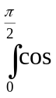⁷xsinxdx | Marks  2
(b) | Find 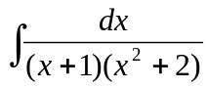 | 4
(c) | Use the substitution 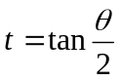to evaluate  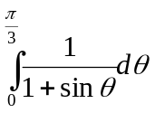 | 4
(d) | (i) Find the equations to the two tangents to the hyperbola 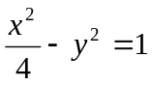 which are parallel to the line 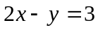.  (ii) Show that the distance between these two tangents is 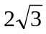 units. | 3  2

QUESTION 2: START A NEW PAGE

(a) | The diagram shows the graph of  for 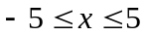.  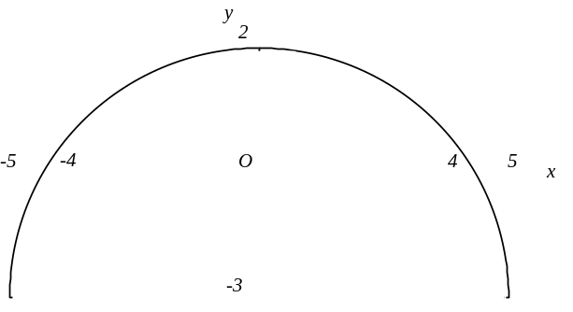  Draw separate sketches of the graphs of the following for 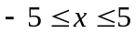.  (i) 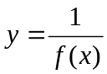  (ii) 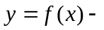||  (iii) 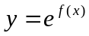  (iv) 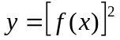 | Marks  2  2  2  2
(b) | Points P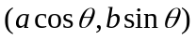 and Q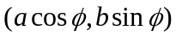 lie on the ellipse  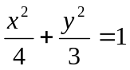, where 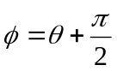.  (i) Show that the gradient of the tangent at Q is 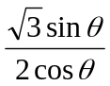.  (ii) If is the acute angle between the tangents at P and Q prove that 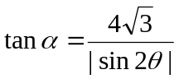  (iii) Find the value of 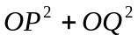 where O is the centre of the ellipse. | 2  3  2

QUESTION 3: START A NEW PAGE

(a) | (i) If 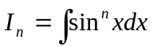 show that:  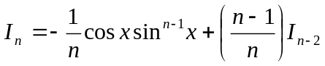 for 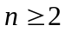  (ii) Hence find 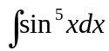. | Marks  3  3
(b) | Points 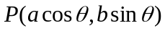, 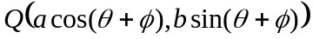 and 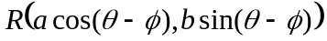 are three points on the ellipse  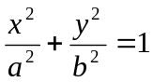.  Show that OP bisects the chord QR, where O is the origin. | 4
(c) | (i) Use the substitution of to show:  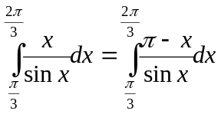  (ii) Evaluate 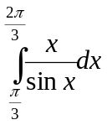  [You may assume 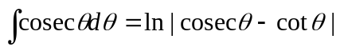] | 2  3

QUESTION 4: START A NEW PAGE

(a) | Evaluate: 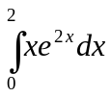 | Marks  2
(b) | (i) Sketch the following graphs for 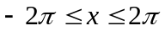 on the same number plane without using calculus.  (α) 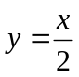  (β) 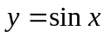  (ii) Sketch on a separate number plane the graph of  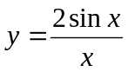 for . | 2  2
(c) | A hyperbola has the equation:  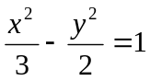.  (i) Find the coordinates of the foci.  The equation of the tangent to the hyperbola at 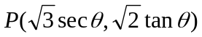 is:  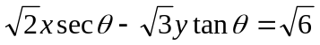.  (Do not prove this equation)  (ii) Show that the equation of the normal at P is:  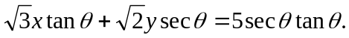  The tangent and normal to the hyperbola at P cut the y axis at T and N respectively.  (iii) Show that the circle with TN as diameter passes through the foci of the hyperbola. | 2  2  5
END OF EXAMINATION

